**DIFFERENT TYPES OF DRUGS AND ITS STRUCTURE**



Submitted as a part of practical course of

+2 Science in Chemistry

Submitted to :

**SHREE SHANTI BHAGWATI SECONDARY SCHOOL**

**LETANG-4, MORANG**

**CLASS : 12**

**ROLL NO : 15**

**Date of submission :**

**LETTER OF APPROVAL**

This is to endorse that the report entitled "Different types of drugs and it's structure" has been carried out by for the partial fulfillment of class 12 of science. They worked enthusiastically with sincere interest throughout this project. This report embodies their own work and has been done under my supervision. I hereby, approve this report for the presentation and submission in the examination.

Date : Chaitra, 2079

**Shanti Prashad Chamlagain**

Department of Science

i

**ACKNOWLWDGMENT**

This file report is our come kind guidance, direct guardianship and precious suggestion of our respected supervisor or this excursion associate proof.

We would like to express our gratitude toward all those staff of medical who were really cooperative in our study and activity responded to our queries and keenly participate in the interaction.

We are also very thankful to all teacher and non teaching staff of the Shree Shanti Bhagwati Secondary school and my parent for this wonderful support and made this event wonderful with drugs. Who always remained based us and made us always felt comfortable to accomplish this task.

**ii**

**ABSTRACT**

Drug addiction is a preventable disease. Through scientific advances we now know much more about how exactly drugs work in the brain, and we also know that drug addiction can be successfully treated to help people stop abusing drugs and resume their productive lives. Most countries have legislation designed to criminalize some drugs. To decrease the prevalence of this problem in our setting: increase awareness, promoting additional research on abused and addictive drugs, and exact implementation of existing laws are strongly recommended. We should also deserve renewed attention on prescription drug abuse. It is imperative that as a nation we make ourselves aware of the consequences associated with drug abuse. Otherwise devastating effects of drug will destroy the manpower and economic growth of the country.

**iii**

**DECLARATION**

I hereby declare that the work present in this report has been done by myself. This report has been prepared after the medical visit on chaitra, 2079 B.S. medical staff interactions queries and observation were done in the medical and literatures were reviewed from the various sources for the secondary information to makes the report to partial fulfillment of class 12.

Laxmi Acharya

2079, chaitra

iv

**CONTENTS**

1. LETTER OF APPROVAL…………………………………………….…..….i
2. ACKNOWLEDGEMENT…………...……………………………………….ii
3. ABSTRACT……………………………...…………………………………...iii
4. DECLARATION……………………………………………………….…….iv
5. INTRODUCTION……………………………………………………………1
6. METHODOLOGY…………………………………………………………….2
7. CHARACTERISTICS AND CLASSIFICATION OF DRUGS………………3
8. ADVANTAGES AND DISADVANTAGES OF DRUGS……………………5
9. CONCLUSION………………………………………………………………..6
10. REFERENCE………………………………………………………………….7

v

**INTRODUCTION**

Drugs is a substance used in prevention and treatment of diseases in human beings. According to World Health Organization (WHO), " a drug is defined as any product that is used to modify or explore physiological system or pathological states for the benefit of recipient.

Drugs are chemicals and substance that affect both your mind and your body. The prolonged use of drugs may lead to physical and psychological dependence. An overdose of any drug may lead to death.

The word 'drug' is derived from the French word 'drogue' which means a dry herb. In ancient times, people used many herbs for the treatment of different disease. In Nepal a collection of many medicinal plant along with their diagram and medicinal value can be found in a book called 'chandra Nigantu'.

The process of treating disease by using drugs is called chemotherapy. Paul Ehrlich, in 1904 indicated that chemical can interface with the proliferation of invading microorganism at a concentration that is tolerated by the host. This is the principle of chemotherapy. Hence, Paul Ehrlich is called as father of chemotherapy.

1

**METHODOLOGY**

The family will initate continuous and gradual methodological steps to help the person gain self confidence and self-help. Effective slogans and promotional activities for social awareness will be published about different types of drugs and its structure. There are plans to extend the program to all secondary school and the municipal social welfare department and NGOs may be involved in this project.

2

**Characteristics of drugs**

1. The action of drugs should be localized at the site where it is desired to act.
2. It should be efficient.
3. It should have minimum side effect.
4. It should not injure host tissue.
5. It should not make the host cell resistant to the drug after its use for a long time.

**Classification of drugs.**

* On the basis of the therapeutic action, drugs are two types :-

i) Chemotherapeutic agents

ii) Parmacodynamic agents

i) Chemotherapeutic agents.

These drugs are used to treat infectious diseases. For example antibacterial, antiviral, antifungal, etc.

1. Antibiotics

These are substances originally produced by various species for microorganism which inhibit the growth of other organism and unltimately destroy them even given in low communication.

Penioitin Chloramphenical

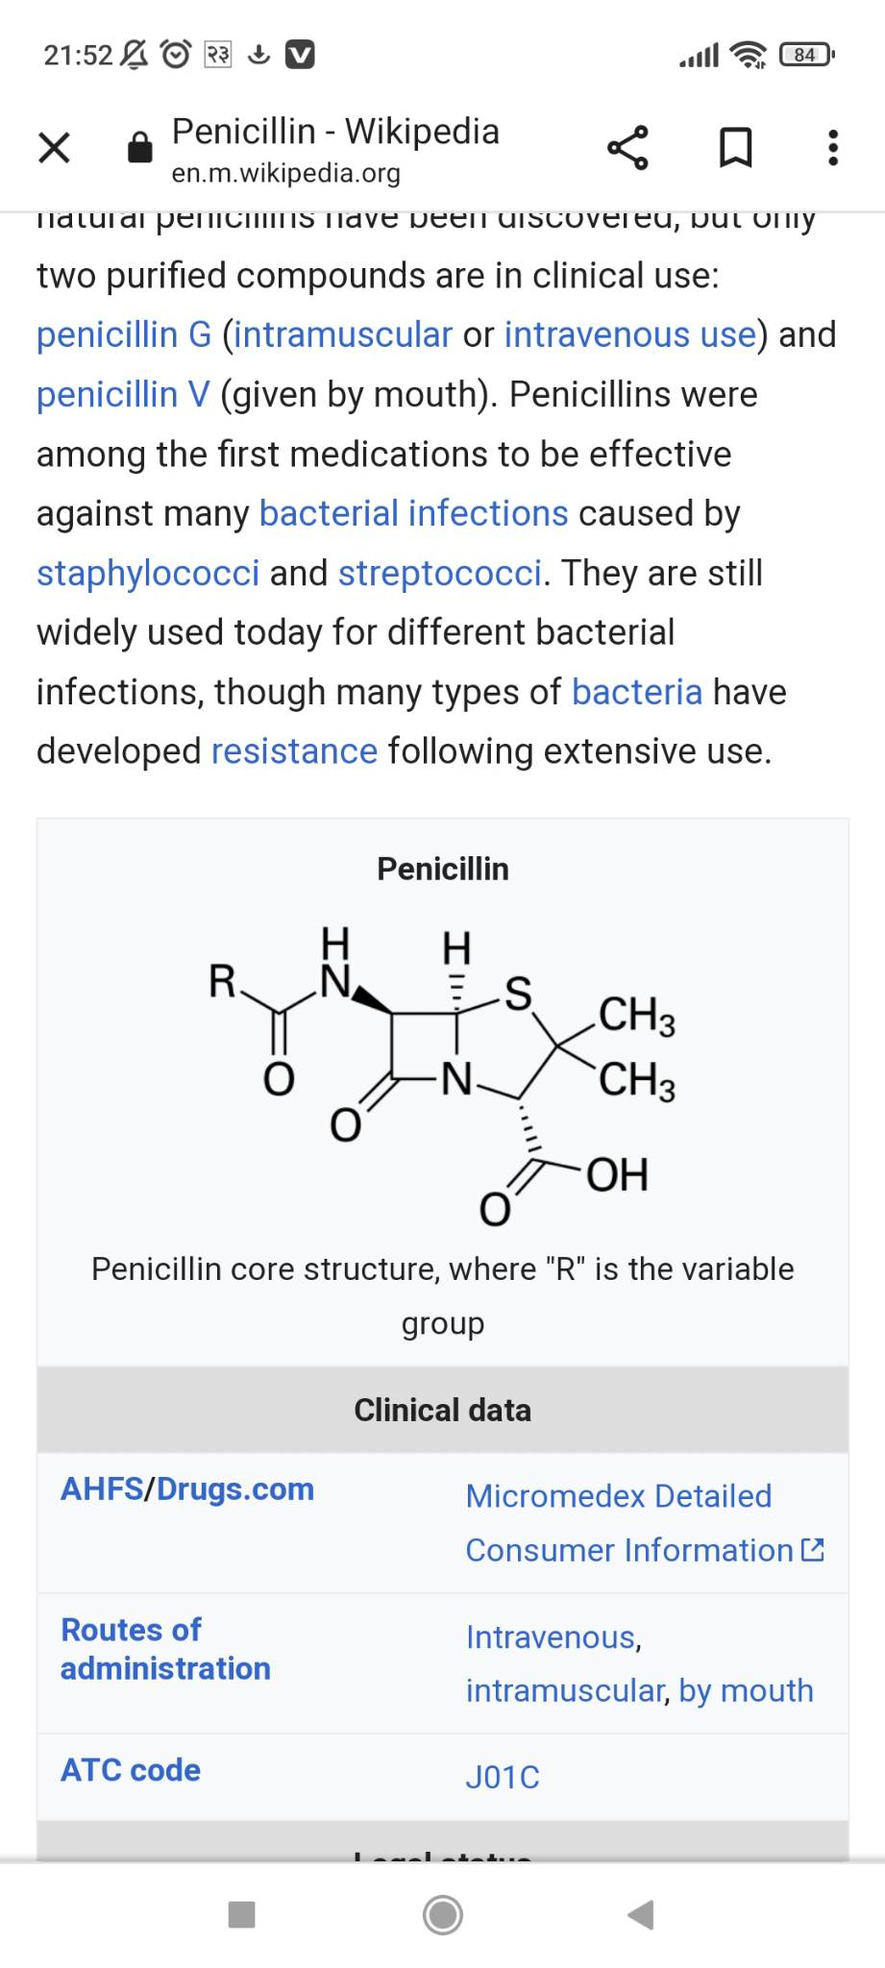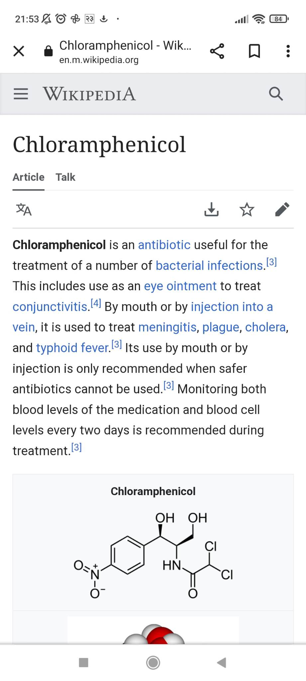

ii) Pharmacodynamic agents.

The disease conditions in human beings which appear due to functional disorder or degradation of body but not due to invading microorganism. For example:- anemia, cancer, depressions, diabetes. The chemicals used to reduce such disease conditions are called pharmacodynamic agents.

1) Antipyretis : The drugs which are used to lower body temperature to normal in high fever are caused as antipyretics. Example.

Paracetamol.

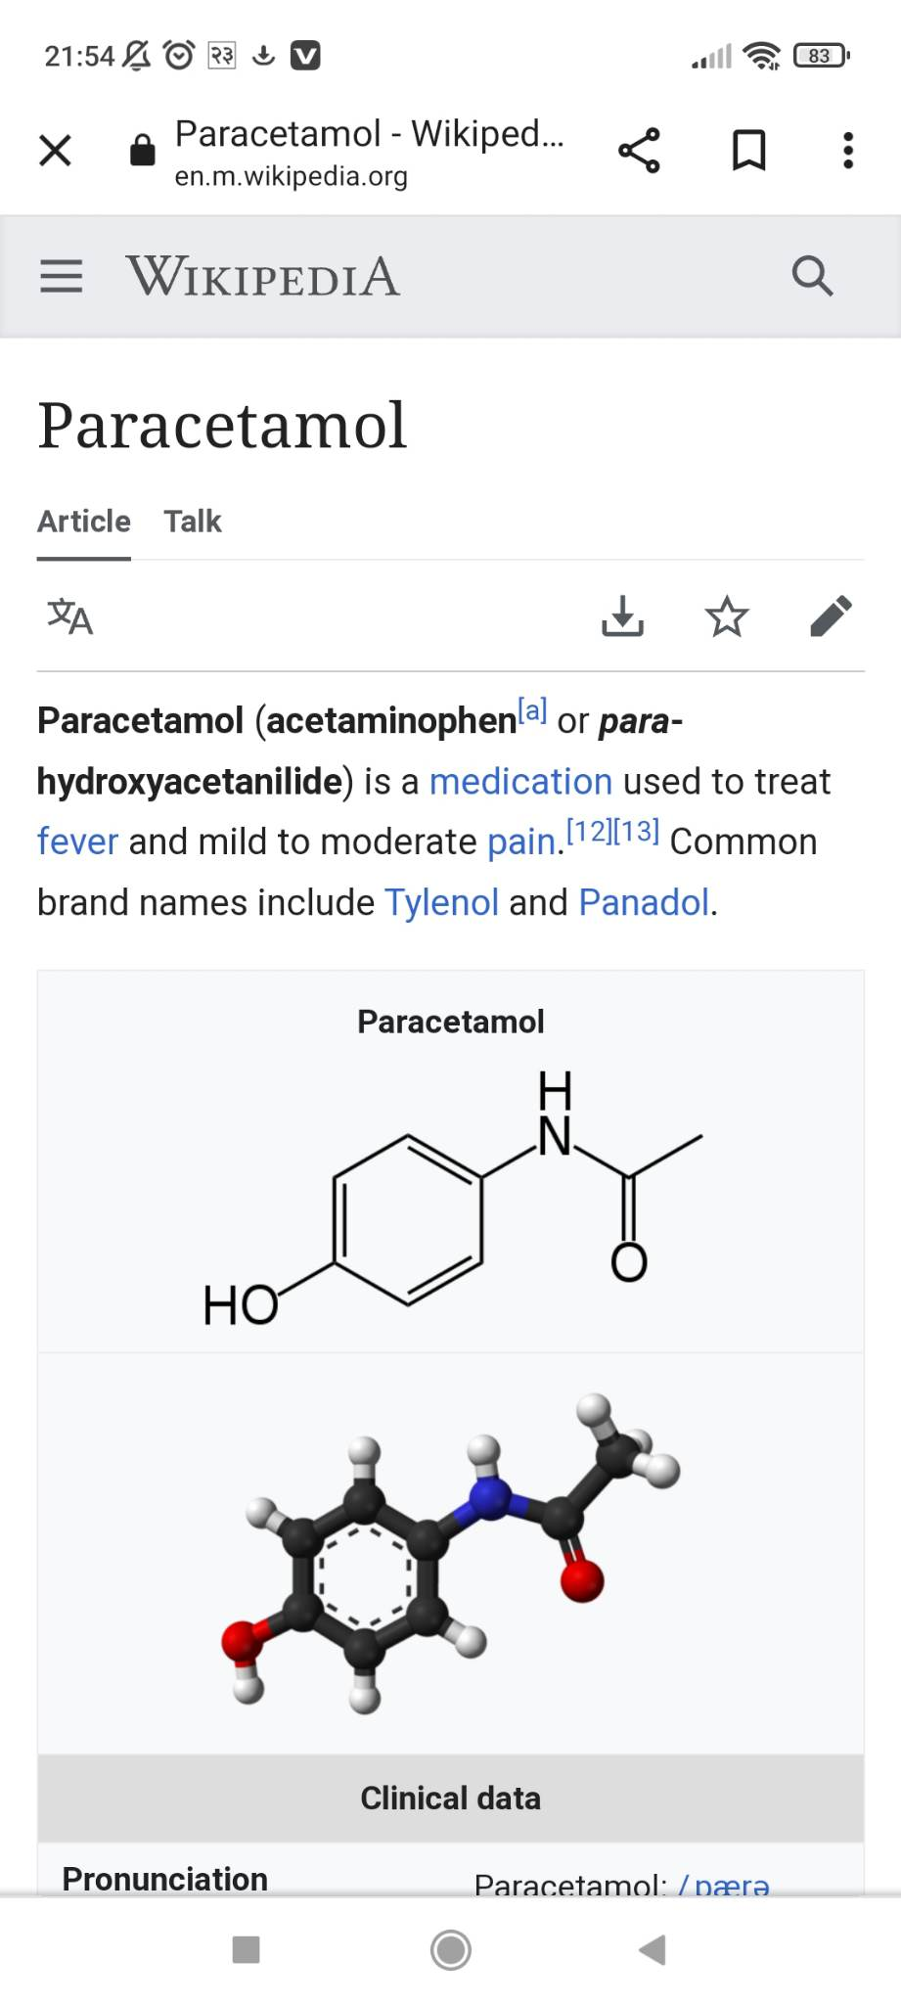

3

2) Analgesis : The drugs which are used to relieve pain without loss of consciousness are called analgesics. They are commonly called pain killers.

Novalgin

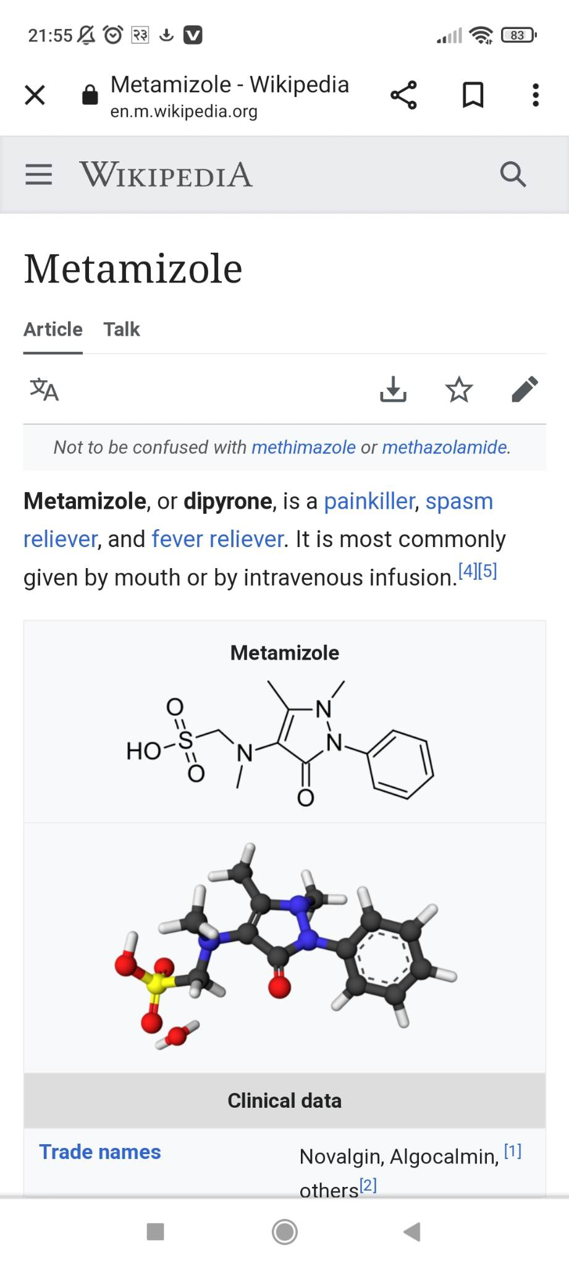

3) Anti diabetic drugs.

Metaformin.

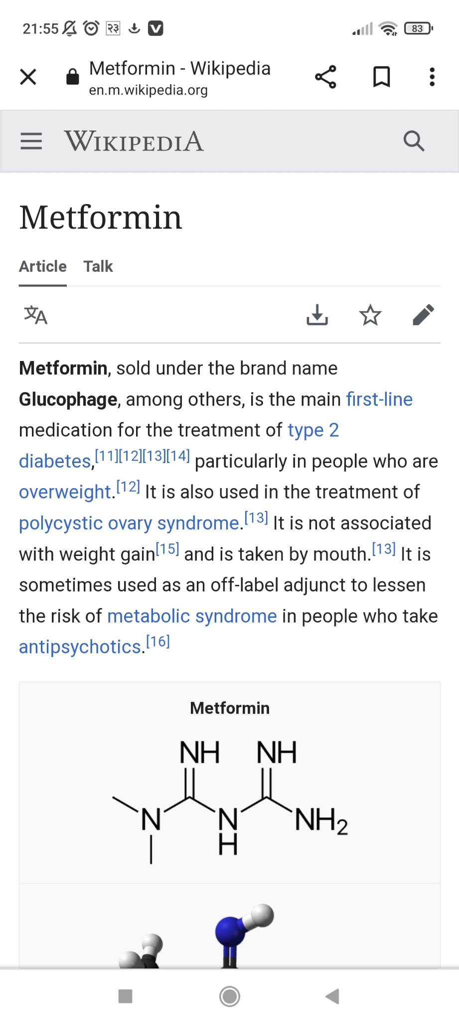

4) Drugs for cardiovascular disease.

Amyl nitrite.

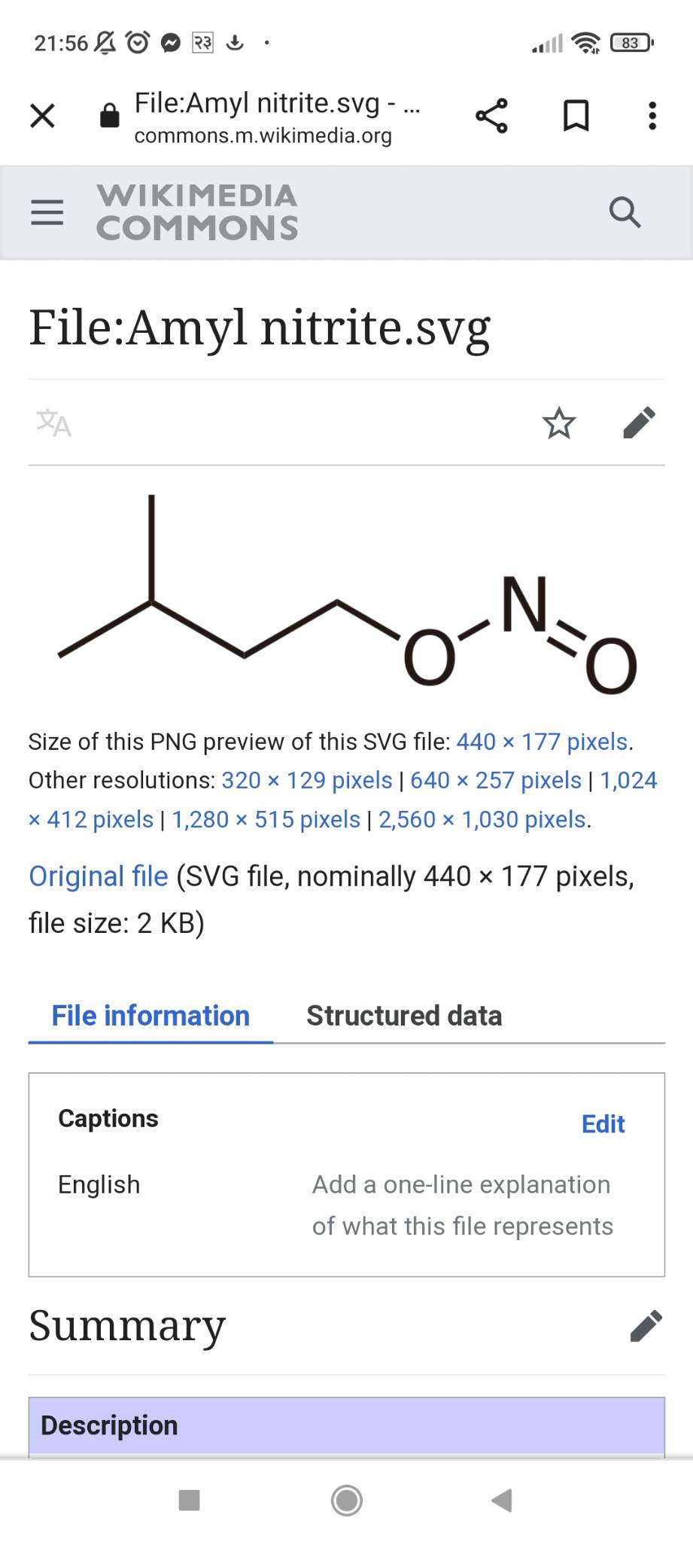

4

**Advantages of using drugs.**

1. Drugs definitely help in tearing fatal disease like cancer which other medicine can't.
2. It has a positive effect in the treatment of the syndromic complex or mental addiction.
3. Recovery of common disease.
4. Also for the plant growth.
5. To cure the disease.
6. Use for manufacturing medicine.
7. For fell stressed out.

**Disadvantage of using durgs.**

1. A large number of drugs affects negatively the central nervous system of human beings.
2. Some drugs like meth are very dangerous for lungs and become the reason of high blood pressure.
3. The problem of constipation and bad teeth are also some worse side effects of using drugs.
4. Some medical drugs ecstay increase the confidential level but these are not long term solution to improve mental stage of any human being.
5. Drugs also increase the rate of heart and become the reason of mental disorder such as depression, anxiety and stress.
6. It damage the body parts.

5

**Conclusion**

In conclusion, I have talked about the structure of drugs. Advantages and disadvantage of drugs and effects of drugs in our society, and what the outcome and problems it makes within our community and our family. I will also conclude that there is a better way instead of using drugs, the best way is to seek an education and try and stay busy instead of going the wrong way about thinking using the drugs.

6

**Reference**

1. WWW.PWC.com
2. https://integrity.thomson.pharma.com
3. https://cortellis.thomsonreuterlifescience.com
4. https:// www.Drugbank.com

7